Master Student Affiliation Agreement Request
This form will only be accepted from a CHST Hosting Department
Requests are not accepted directly from schools

Request Date: Click here to enter a date. CHST Department: Click here to enter text.
Requestor’s Name (must be CHST employee):Click here to enter text.
Type of Contract: Choose an item. Supply Portal Number: Click here to enter text.
Renewal Contract Number: Click here to enter text. (contract requests cannot be submitted without Supply #)
If new contract you must have school register and get number
For contract renewals, Student Services can look up number

Start Date for Contract: Click here to enter a date.
Agreement may take 30-90 days to execute depending on the cooperation of the school. Date requested should allow for time to process.

School Requested: Click here to enter text. School Tax ID # Click here to enter text.
School name must be exactly as appears on W-9 tax form Must provide School W-9 form

School type: Choose an item. If other, please explain: Click here to enter text.

School Contact information:
Name: Click here to enter text. Title: Click here to enter text.
Email: Click here to enter text. Phone #: Click here to enter text.
School Address: Click here to enter text.

Number of students expected: Click here to enter text. Duration of stay: Click here to enter text.

Are students accompanied by instructors or precepted by Children’s staff? Choose an item.

Resources provided by hosting department: (Preceptor/coordinator, space, other?)
Click here to enter text.

What is the return on investment for your department/Children’s? Choose an item.
Click here to enter text.

How does this partnership align with Children’s strategic goals? Choose an item.
Click here to enter text.

Is there an organizational relationship that should be considered? Choose an item. Choose an item.
If yes, please elaborate: Click here to enter text.

Does this type of student fill a pipeline need for Children’s? Choose an item.

Are Children’s employees enrolled in this program? Choose an item.

How many students have been hired from this school in the last year? Click here to enter text.

Considerations when submitting a request:
- Schools must sign CHST Master Student Affiliation Agreement; they cannot submit their own contract
- Master contracts cover all CHST locations and all school programs
- Requests for individual discipline will be considered on a case by case basis

Return this form by email to StudentAffiliationContracts@childrens.com with the schools W9

Directions for schools to register in Supply Portal
(only for new contracts)

Before an Affiliation Agreement can be processed, schools are required to register at https://chstprod-law-lm01.cloud.infor.com:1442/lmscm/SourcingSupplier/html/SourcingSupplier?csk.SupplierGroup=CMC&csk.CHP=LMPROC
The Supplier Portal was created to facilitate the exchange of information between Children’s Health Contract Administration Team and our suppliers. Registration for the Supplier Portal will allow us to keep your contact information up-to-date and allow us to reach out to you for upcoming bidding opportunities.
For inquiries regarding Supplier Portal, please email StudentAffiliationContracts@childrens.com.
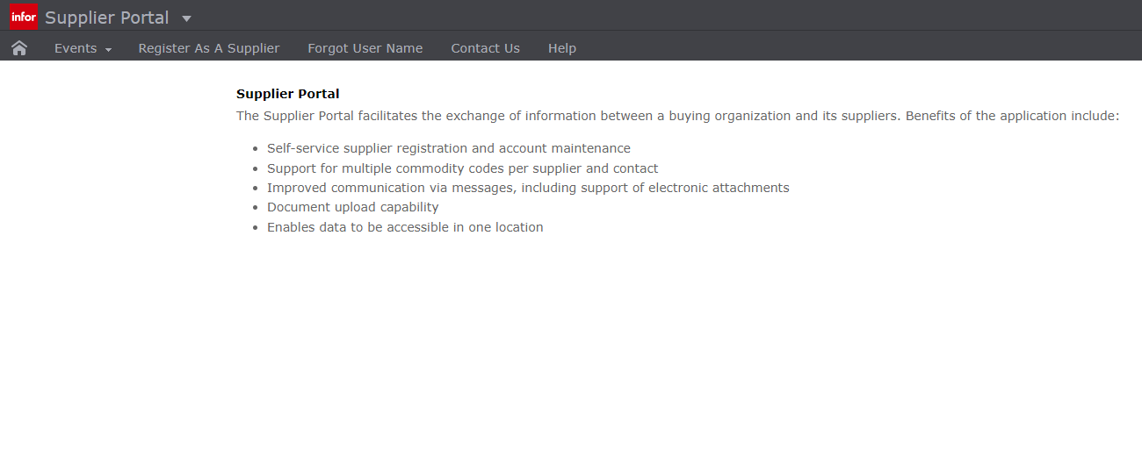

STEPS:
- Click on “Register As A Supplier”
- Follow the directions for each page until complete
- Send your portal number/supplier number to StudentAffiliationContracts@childrens.com
Once you are registered as a supplier, please forward the email you get with your number to StudentAffiliationContracts@childrens.com
Contract request will not be processed without W9 and Supply Portal number

